Hyphens are used with a word that has a prefix, to avoid doubling up a vowel and changing the pronunciation.

***Re-enter as opposed to reenter.***

We sometimes need to use a hyphen within a word that has a prefix to make the meaning clear.

***Recover has a different meaning to re-cover.***

Hyphens are used in many compound words to make the meaning clear and turn it into a compound adjective or a compound noun.

***Man-eating tiger as opposed to man eating tiger.***

***Passer-by as opposed to passer by.***

We use hyphens to show that a word is continuing on the following line.

***At the amazing safari, we saw enormous elephants, ferocious lions and rampaging rhino-ceroses.***

We use hyphens in the numbers from twenty-one to ninety-nine where two numbers are put together to   
make another.

***Twenty-one, twenty-two etc.***

We use hyphens in informal phrases with words that are not usually used singly.

***Wishy-washy, free-for-all***

We usually use a hyphen after the prefixes all- and self-. They make compound adjectives and nouns.

***Self-portrait, all-knowing etc.***

**Hyphen**

A colon can be used to:  
1. introduce a list  
**There are three things Sarah needs from the shop: crisps, bread and milk.**

2. link independent clauses together to expand sentences. They often introduce an explanation.  
***You often see dogs panting in summer: it helps them cool down.***

**Colon**

It follows grammatical rules like the correct use of [verb tenses](https://www.theschoolrun.com/what-is-verb-tense) and [pronouns](https://www.theschoolrun.com/what-is-a-pronoun).

**Non-standard English:** ***They ain’t got nothing.***

**Standard English: *They haven’t got anything.***

**Standard English**

Possessive pronouns are used to show ownership of a person or thing.

***Tom is a good friend of mine.***

***Can you tell your brother, I’ll meet him after school?***

***The teacher left their coat.***

**Possessive Pronouns**

Brackets are used when you want to add **parenthesis** (extra information), or a **thought**, to a sentence.

***My little sister threw a wobbly (better known as a tantrum) when she couldn’t have the toy.***

***The present turned out to be a magnificent painting (definitely not what I was expecting).***

**Brackets**

**Dash**

A semi-colon can be used to:  
1. separate items in a list when the items have commas.

***We visited China, Japan and Thailand in the summer; Canada, Alaska and Hawaii in the winter; and Italy in Autumn.***

2. separate two **closely related** independent clauses instead of using a conjunction.

***James enjoys playing tennis; he doesn’t like football.***

A dash can be used to:  
1. indicate parenthesis (extra information) within a sentence

***I miss Amelia – my best friend – everyday.***2.separate two independent clauses (more commonly used in informal writing)

**My younger brother can be good fun – he can also be a complete pain at times.**

**Semi-colon**

Auxiliary verbs are verbs which form the **tense, mood and voice** of other verbs. They are also known as 'helping verbs'.

She ***has*** bought some tropical fruits.

He ***will*** bethe best goalkeeper.

You ***are*** never too old to learn.

**Auxiliary Verbs**

**Advice or obligation;**

**Habits; **

**Permission; **

**Ability; **

Modal verbs are auxiliary verbs which cannot usually work alone. They are used with a main verb.

Modal verbs can also be used to show:

Pupils ***must*** wear a uniform.

You ***should*** not smoke.

**Habits;**

I ***will*** often have cereal for my breakfast.

We ***shall*** always enjoy a walk in the park.

**Permission;**

***May*** I leave a few minutes early?

Please ***can*** we have an ice-cream?

**Ability;**

My Grandfather ***could*** draw very well.

I ***can*** ride my bike.

**Modal Verbs**

***The trophy was lifted by the winner of the race.***

***.***

***The* winner** ***of the race lifted the trophy.***

**Active voice** = the **subject** of the sentence performs the **action** to the **object**.

***The* winner** ***of the race lifted the trophy.***

**Passive voice** = the **subject** has the **action** 'done' to it – the **object** of the sentence comes first.

***The trophy was lifted by the winner of the race.***

**Active/Passive voice**

The **present progressive tense** is used to describe an activity currently in progress.

***I am reading right now.***

***It is raining cats and dogs.***

***We are watching a movie.***

**Present Progressive Tense**

**Determiners**

A relative clause can be used to give additional information about a noun.

They are introduced by a relative pronoun like **'that'**, **'which'**, **'who'**, **'whose'**, **'where'** and **'when'**.

**Rachel liked the chair, *which was very comfortable.***

**I was cross at the dog, *who had just eaten my homework.***

**Relative Clause**

**Relative Clause**

**Fronted Adverbials**

The **subjunctive mood** is for expressing wishes, proposals, suggestions, demands or imagined situations.

**I wish it *were* Friday.**

**If I were a millionaire, I would buy a boat.**

* **It's crucial *that* he sing in the performance.**

**I hope *that* you are able to come.**

* (The verbs ‘were’ and ‘that’ are written in the subjunctive mood)

**Subjunctive Mood**

The **past progressive tense** is used to describe an ongoing activity in the past.

***They were painting the fence.***

Often, the past progressive tense is used to set the scene for another action.

***They were painting the fence while I was cutting the grass.***

**Past Progressive Tense**

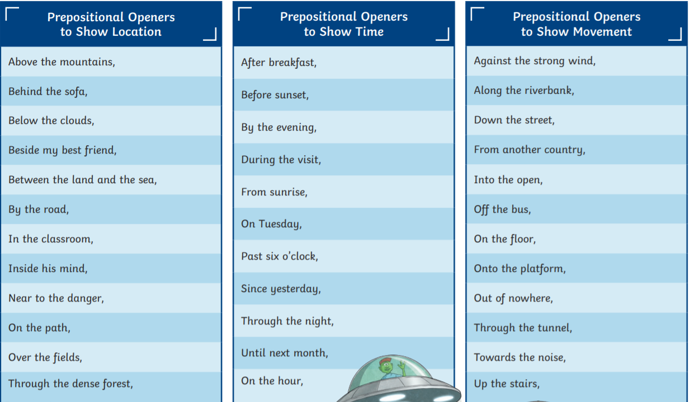

They can join two verbs, two nouns, two adjectives, two phrases, or two independent clauses.

**Co-ordinating Conjunctions**

A **preposition** is a word that tells you where or when something is in relation to something else. They are usually placed directly in front of a noun.

**Prepositions**

**Independent clause**

An independent clause is a clause that can stand alone as a sentence.

**Dependent clause**

A dependent clause (or subordinate clause) is a clause that cannot stand alone as a complete sentence because it does not express a complete thought.

**Inverted commas**

Inverted commas are used to show where direct speech or a quotation begins and ends in a sentence.

**Prefix**

A letter or group of letters added to the **beginning** of a word to change the meaning or make a new word.

**Suffix**

A letter or group of letters added at the **end** of a word to make a new word.

**Synonym**

A word or phrase that means exactly or nearly the same as another word or phrase.

**Antonym**

An antonym is a word that means the opposite of another word.

**Noun**

A noun is a word that represents a person, thing, concept, or place.

**Verb**

A verb is a word used to describe an action, state or occurrence.

**Adverb**

An adverb is a word that describes how an action is carried out.

**Adjective**

An adjective is a word that tells us more about a noun.

**Adverbial**

Adverbials are words that gives us more information about a verb.

**Compound Sentence**

A compound sentence joins two independent sentences together using a coordinating conjunction.

**Complex Sentence**

A complex sentence joins an independent sentence and a dependent sentence together by using a subordinating conjunction.

**Quick SPaG Vocabulary**

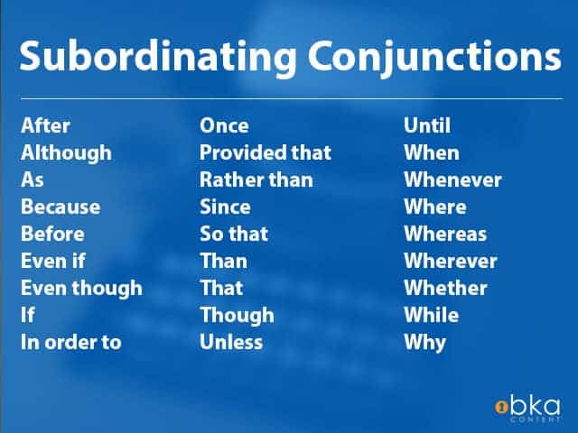

He inspires me always ***because*** he believes in me.

She manages to climb ***even though*** she’s scared of heights.

A subordinating conjunction is **a word or phrase that links a dependent clause to an independent clause**.

**Subordinating Conjunctions**

