Sunflower Home Learning: Week beginning 22nd June

Hello Sunflowers,

I hope you are all keeping well and enjoying the lovely sunshine again. I have been enjoying all the beautiful flowers in my garden. The little girl next door to me has been making daisy chains. Do you know how to make one? She was making necklaces, bracelets and heart shapes with daisies. Perhaps a grown up could show you how to join the daisies together. Here is your home learning for this week. Love from, Mrs. Brady ☺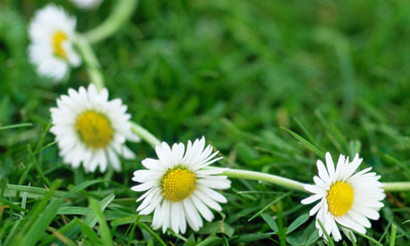

Other task:

<https://www.youtube.com/watch?v=eIo88snD0Fc>

<https://www.youtube.com/watch?v=ugNr1-gxDjc>

<https://www.youtube.com/watch?v=oHo1ro1Zef0>