Sunflower Home Learning: Week beginning 29th June

Hello Sunflowers,

It’s been lovely weather again. I have been playing a game in my back garden called Croquet. I wonder if you have been playing any games outside too? 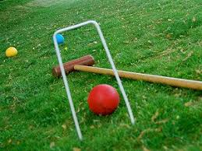

I hope you are all keeping well and enjoying spending time with your families. Here is your home learning for this week. Love from, Mr. Brady ☺

Other task:

<https://www.youtube.com/watch?v=-qtCB7CYH3I>

<https://www.youtube.com/watch?v=DezS9N7el5Y>

<https://www.youtube.com/watch?v=vbPZbZEj7mY>