Year 1 Summer Term News
Dear Parents and Carers,

Welcome to Year 2! I am really looking forward to teaching your children again this year. I hope you have all had a lovely summer break. I would like to invite you to join us for our Reading Breakfast on Tuesday 16th September at 9.30 am.

Best wishes, Mrs. Brady

Curriculum
We have a very exciting curriculum planned for this term. The highlights will be: reading exciting stories; ‘The Egg Box Dragon’ and ‘The Dragon Machine’ and designing and making healthy fruit smoothies. Please see the curriculum plan for more details.
Newsflash: We will be having an artist’s Hook Day on Tuesday 9th September. The children can come to school dressed up as an artist (hat/beret, an apron or Dad’s old shirt for a smock.) They will have a fun-packed day of learning new art techniques, sketching, painting and creating exciting pieces of art work!
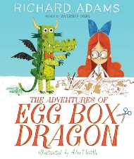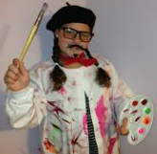

Home Learning

Reading Please read reading books at least three times or more a week at home. Please record all home reading in your child’s diary.
Phonics Your child can improve their phonics by watching Phase Phonics with Felix videos on YouTube.
Maths Activities can be found at http://www.topmarks.co.uk/maths-games/5-7-years/counting
Home Learning: Please choose 2 different ‘enrichment ideas’ to do each week and also complete the ‘weekly essentials’. Please hand in home learning books and reading books every Thursday morning.

Further info
- PE: Please ensure your child has their full PE kit in school every day.
- Water bottles: Please encourage your child to bring fresh water to drink every day.

Look out for…
- Star of the Day certificates, special stickers and updates on Facebook and the Pumpkin class blog!


