
We hope that you have had a fantastic summer break and look forward to welcoming you into year 4/5.
This newsletter should cover any questions you may have, however, if you have any further questions then please feel free to e-mail or speak to myself, or a member of the support team. We are always happy to help.

Our learning this term
This term we will be looking in history, at significant explorers, such as Ernest Shackleton, who ventured to the extreme corners of the earth. We will also learn about local history, including the fishing heritage of Grimsby. Our core books of Shackleton’s Journey and Ride the Wind will help us tie some of our English learning into our topic. We will also delve into the story The Wolf Wilder, by Katherine Rundell. In maths, we will be returning to core calculation skills before moving on to fractions work. In art, we will learn about a variety of different ways to create portraits, looking at the work of artists from different cultures, and in music we will learn how to read notation. Science learning will focus on properties and changes of materials. For more curriculum information, please look at the medium term plan!

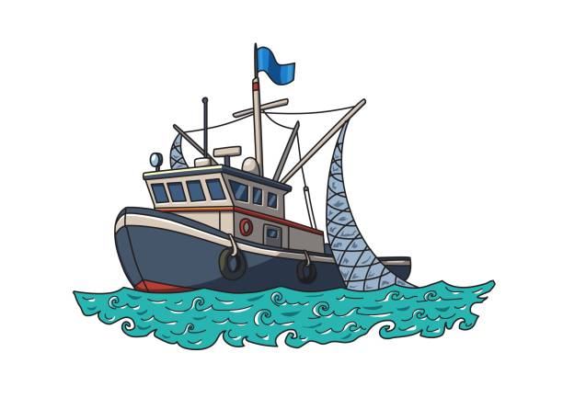



Home Learning
Our home learning will be split into 2 categories: weekly essentials and enrichment ideas.
Weekly Essentials:
Reading: Please continue to support your child’s home reading. We ask that they read for a minimum of 3 times a
Enrichment Ideas:
Please choose some of these activities over the whole of the term to show creativity with your home learning.

General Reminders
- PE: Please bring kits in every week. We will usually have our PE lesson on a Monday.
PE is a compulsory element of the curriculum like any other subject and missing kit will be followed up.
- Uniform: Can you please make sure uniform & PE kits are clearly labelled to avoid confusion when children misplace some of their belongings.
- Coats: As the weather is changeable and we like to use our outdoor learning environment, please ensure that your child has a suitable coat with them regardless of the weather conditions.
- Water bottles: The children should bring in a water bottle from home with a sports style cap, which they can access throughout the day. They will be encouraged to change their water regularly and take them home each evening to be washed. Please make sure your child’s name is written clearly on their water bottle.
- Rucksacks: Your child should only need to bring their packed lunch, a water bottle and their reading book if they wish to change it. PE kits can be stored at school throughout the term. As children should not be bringing non-essential items in from home, rucksacks should not be brought into school, especially as there is limited storage space in the classroom.

Key Dates:
- September 8th – Hook Event – Extreme Weather
- September 9th – Fairtrade Fortnight
- September 19th – Jeans for Genes fundraiser – Wear denim!
- September 25th – Macmillan Cake Sale – Community invite to watch us perform
- October 3rd – Harvest
- TBC – Autumn Craft Event
- November 11th – Anti-Bullying Week
- November 16th – Road Safety Week
- November 21st – Children in Need – Fundraising and fun activities
- December 3rd – Christmas Fayre – More information to follow!
- December 8th- Christmas show

We will also be observing other important events this term, including: World First Aid Day, International Day of Democracy, Recycling Week, Black History Month, World Mental Health Day, Yom Kippur, Diwali, Remembrance, UK Parliament Week – Further info on our SMSC Long Term Overview on the website.

Trip – Fishing Heritage Centre –

The office will be available to discuss any support with payments.

Thank you for reading.

