Hello and welcome to Year 6 Barley Class. We have some fantastic learning opportunities this term that we look forward to sharing with you! I look forward to a great year with you all!

Learning this term
Our topic this term is ‘’ Ancient Greece’ where we have decided that we would like to find out the answers to the following questions: Can I learn about Greece and place the Ancient Greek civilisations in time? Can I discover and explain the daily life in Ancient Greece?
Can I understand the impact of the Ancient Greek civilisation on the modern world?
In Geography children will deepen their understanding of how goods and services are traded around the world. They will explore the UK’s trade links today and in the past, finding out about goods that are imported and exported. In Art we will be studying street art and how artists convey a message. Electricity is our focus in Science. We will compare and give reasons for variations in how components function. Our class book this half term will be by the author Kiran Millwood… We will be reading The girl of ink and stars. Please look at our Medium Term Plan to find out more about the exciting learning planned for this term.

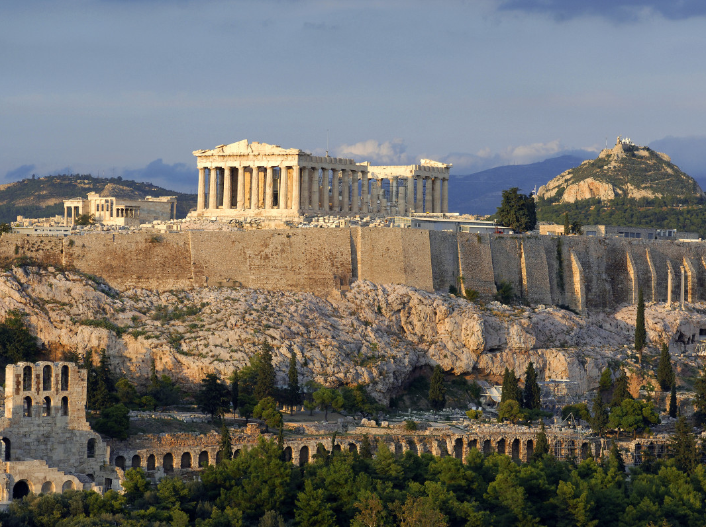

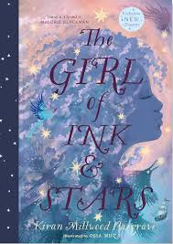

Our Hook Day for this topic will be on Tuesday 9th September. Children can dress up on this Hook Day e.g. Ancient Greeks, for this event, if they wish. We will be focused on music, art and dance, so please take this into consideration when creating your costumes.

Look out for…
- 9th September – Hook Day – Ancient Greece
- 19th September – Jeans for Genes – Wear jeans to school for a special fundraising event to support families impacted by genetic conditions.
- 25th September – MacMillan Fundraiser – Children will all perform songs or poetry to help raise awareness for an important cause
- October- Big Draw festival
- 2nd October- Wrates Individual photos
- 3rd October – Harvest donations most welcome
- TBC October – Autumn craft event
- 10th November- Antibullying Week
- 16th November- Road safety Week
- 21st November – Children in Need
- 3rd December- Christmas fayre
- 10th December- Year 6 Carol Service at the Church 5pm, all welcome
Keep checking class blogs and Facebook for regular updates to our learning journey!

General Reminders
- PE: Our main PE lessons will be on Monday - We try to do as many lessons outside as possible so it is important that the children have both inside and outside PE kits including suitable footwear and warm clothing. Please ensure that children with long hair have it tied back and earrings are removed. We would suggest you leave their kit at school so it is always available.
- Uniform: Can you please make sure uniform & PE kits are clearly labelled to avoid confusion when children misplace some of their belongings.
- Home Learning: Please see the Home Learning book for this term’s home learning tasks. Home learning activities are available on TT Rockstars and Spelling Shed. The expectation is that children will record 3 reads each week, which will contribute towards a reward at the end of the half-term.

Have a wonderful Summer! Mrs Smith and Year 6 Team!

