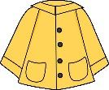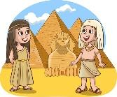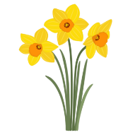

**Home learning**

Our home learning will be split into 2 categories: weekly essentials and enrichment ideas.

**Weekly essentials:**

**Reading** – Please continue to support your child’s home reading. We ask that they read a minimum of 3 times a week whish should be logged in their reading diaries.

**Spelling challenge –** Spelling should be practised on Spelling Shed. These will be tested on a Friday.

**Flashback 4 –** This will be in the form of 4 retrieval questions. This will be a quick task to complete and help children to remember what they have been learning across the curriculum.

**Enrichment Ideas:**

Please choose at least 6 activities over the whole term.

**Our learning this term**

This term, we’ll be exploring Egyptian culture, including its society, historical development, the construction of pyramids, and the fascinating process of mummification.

In Geography, we’ll study Egypt in more detail and compare it to the UK.

Our Science lessons will focus on forces, magnets and light, while in art, we’ll enjoy designing scrolls, making our own paper and creating modern interpretations through zines.

For more details about the exciting learning ahead, take a look at our Medium Term Plan.

At Laceby Stanford, we love to share our learning journey on our class blogs and Facebook page. Don’t forget to check them regularly to see all the amazing work happening in our classrooms!

**Hello and welcome to Daffodil Class!**

I am so happy and excited to be working with the new year 3 children and I am sure that we will have lots of fun over the next year! We have a busy but exciting year ahead of us. This newsletter should cover any questions that you may have, however, if you have any further questions then please feel free to e-mail or speak to myself or a member of the Year 3 team.

We are always happy to help!

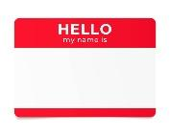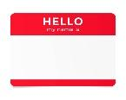

**Important Dates**

9th September – Egyptian Hook Day

19th September – Jeans for Genes Day

22nd September – Reading Breakfast.

25th September – Macmillan Cake Sale

3rd October – Harvest

WB 10th November – Anti-bullying week

11th November – Remembrance Day

WB 16th November – Road Safety Week

21st November – Children in Need

3rd December – Christmas Fayre

11th December – Year 3 Christmas Concert (2pm)

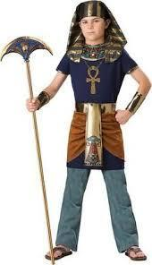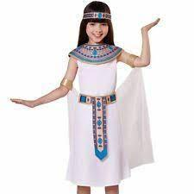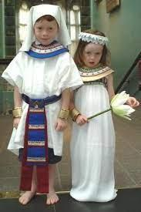

**Here are some ideas for our hook day:**

Thank you!

I hope you have a great summer holiday and I cannot wait to see you in September!

Miss Sutton and the Year 3 team.